Restaurant Simulation User Manual
2017
members
A, B, C, D

Table of Contents
Introduction 2
Application Overview 3
User Interface 3
Operation 3
Operation Description 4
Placing Component 4
Removing Component 4
Merging Table 4
Un-Merging Table 4
Starting the Simulation 5
Stopping the Simulation 5
Pausing the Simulation 5
Saving an Arrangement 5
Loading an Arrangement 6
Saving the Simulation Data 6

Introduction
Restaurant Simulation is an application that can simulate your restaurant arrangement. It allows you to put the table on your desired table and put extra stuff that usually a restaurant has. Then, you can start the simulation to see how the customer interacts with the arrangement. In the end of the simulation, you can get the result how’s your restaurant performing.
In this document, a detailed description for each operation in the restaurant application will be explained. This document purpose is guidance to the user to perform specific task.

Application Overview
In this section is where the overview of the application. Such as, User Interface and Operation.

User Interface
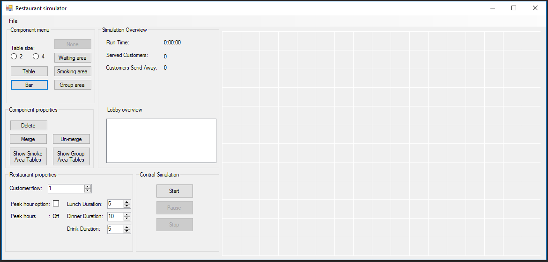
In this section is where the initial screen of the User Interface of Restaurant Simulation application
(Figure 1)

Operation
In this section is where the operation that could be done on our application is listed.
- Placing Component
- Removing Component
- Merging the Table
- Un-merging the Table
- Starting the Simulation
- Stopping the Application
- Pausing the Application
- Saving an Arrangement
- Loading an Arrangement
- Saving the Simulation Data

Operation Description
In this section the description and the detailed steps how to achieve of the listed operation above.

Placing Component
Placing Component is an operation to put a component on the Grid.
How to:
- Choose a Component on Component Menu group.
- If table chosen, you need to determine the size.
- Click on the empty space of the Grid.
- Component is placed on the Grid.

Removing Component
Removing component is an operation to remove a component on the Grid.
How to:
- Click the Delete button on the Component Properties group.
- Choose a component on the grid.
- Component is removed from the Grid.

Merging Table
Merging Table is an operation to merge 2 separate table on the grid.
How to:
- Click the Merge button on the Component Properties group.
- Choose the first table for the merging.
- Choose the second table for the merging.
- Choose an empty space on the Group Area to put the Merged Table.

Un-Merging Table
Un-Merging Table is an operation to un-merge a merged table on the grid.
How to:
- Click the Un-Merge Button on the Component Properties group.
- Choose a merged table on the Grid.
- Choose a free spot on the grid for the first table.
- Choose a free spot on the grid for the second table.

Starting the Simulation
Starting the simulation is an operation to start the simulation to test your arrangement with the customer.
How to:
- Placing Component Operation.
- Determine the Customer Flow on the Restaurant Properties.
- Determine the Peak Hour Option on the Restaurant Properties.
- Determine the Lunch Duration on the Restaurant Properties.
- Determine the Dinner Duration on the Restaurant Properties.
- Determine the Drink Duration on the Restaurant Properties.
- Click the Start Button on the Control Simulation group.

Stopping the Simulation
Stopping the Simulation is an operation to stop a running simulation.
How to:
- Starting the Simulation Operation.
- Click on the Stop Button on the Control Simulation Group.

Pausing the Simulation
Pausing the Simulation is an operation to pause a running simulation.
How to:
- Starting the Simulation Operation.
- Click on the Pause Button on the Control Simulation Group.

Saving an Arrangement
Saving an arrangement is an operation to save a current placed component on the grid.
How to:
- Placing Component Operation
- Click File on the Tool Bar.
- Choose Save/Save as.
- Choose a name and the location to store the file.
- Click Save.
- Your arrangement is saved on .BIN file format.

Loading an Arrangement
Load an arrangement is an operation to load a saved arrangement on your local.
How to:
- Click File on the Toolbar.
- Choose Open.
- Choose a .BIN file for the application
- Click Open.
- Your saved arrangement is loaded on the grid.

Saving the Simulation Data
Saving the Simulation Data is an operation to save the data about the simulation.
How to:
- Starting Simulation Operation
- Stopping Simulation Operation
- Click Save on the Toolbar
- Choose Save Simulation Data
- Choose a name and the location to store the file.
- Click Save
- Your Simulation Data is saved on .TXT file format.

